
Labor Market Information: Awareness and Use
BACKGROUND
Job-Driven Vocational Rehabilitation Technical Assistance Center (JD-VRTAC)

PA OVR was selected as one of 12 state vocational rehabilitation (VR) agencies to receive intensive
Technical Assistance through the Job-Driven Vocational Rehabilitation Technical Assistance Center (JD-VRTAC) to learn about and implement job-driven practices for the project year: October 15, 2015 – October 14, 2016.

JD-VRTAC is a national center for improving VR responsiveness to job-driven needs and is a part of the Institute for Community Inclusion (ICI) at the University of Massachusetts Boston. The Center strives to identify, adapt, embed, and sustain job-driven practices into VR agencies, leading to improved employment outcomes for people with disabilities.

One component of this project involves increasing the awareness and use of Labor Market Information (LMI) during the VR Process.
Click the Next Button to learn about the definition of LMI.
Labor Market Information: Awareness and Use
DEFINITIONS
What is Labor Market Information (LMI)?

Labor Market Information (LMI) can be defined as the systematic collection, analysis, reporting, and publishing of a broad range of data that describes current economic conditions within a given geographic area. LMI includes all quantitative and qualitative data and analysis related to employment and the workforce. The goal of LMI is to help customers make informed plans, choices, and decisions for a variety of purposes, including career planning and preparation, education and training offerings, and job search opportunities.

Characteristics of LMI include, but are not limited to:
- Supply and demand for a particular job type
- Industry and occupational characteristics
- Capacity and immediate results from education, training, and job placement
- Economic and workforce trends
- Needs and expectations of industries and specific occupations
- Perceived value of education and certificate programs LMI can be obtained from a variety of sources.
Click the Next Button to read about the Scope and Purpose of this survey.
Labor Market Information: Awareness and Use
SCOPE AND PURPOSE
This survey is designed to gather information about your current level of awareness of Labor Market Information (LMI), as well as your current level of use. We will ask you about your use of general LMI, as well as the specific LMI available through Labor and Industry’s Center for Workforce Information & Analysis (CWIA) and their PA WorkStats website.

For the purposes of this survey, LMI includes the following components:
- Demographics (e.g, race/ethnicity, gender, age, education level, family status)
- Unemployment rates
- Skill requirements
- Wages and benefits
- Demand for or growth of particular industries or occupations
- Career Projections (e.g., openings, advancement opportunities, wage increases)

Thank you for offering your input through this survey.

Your input will be used to develop a focused training curriculum regarding the use of LMI.

Click the Next Button to begin the survey.
Labor Market Information: Awareness and Use
- What is your current employment classification within OVR?
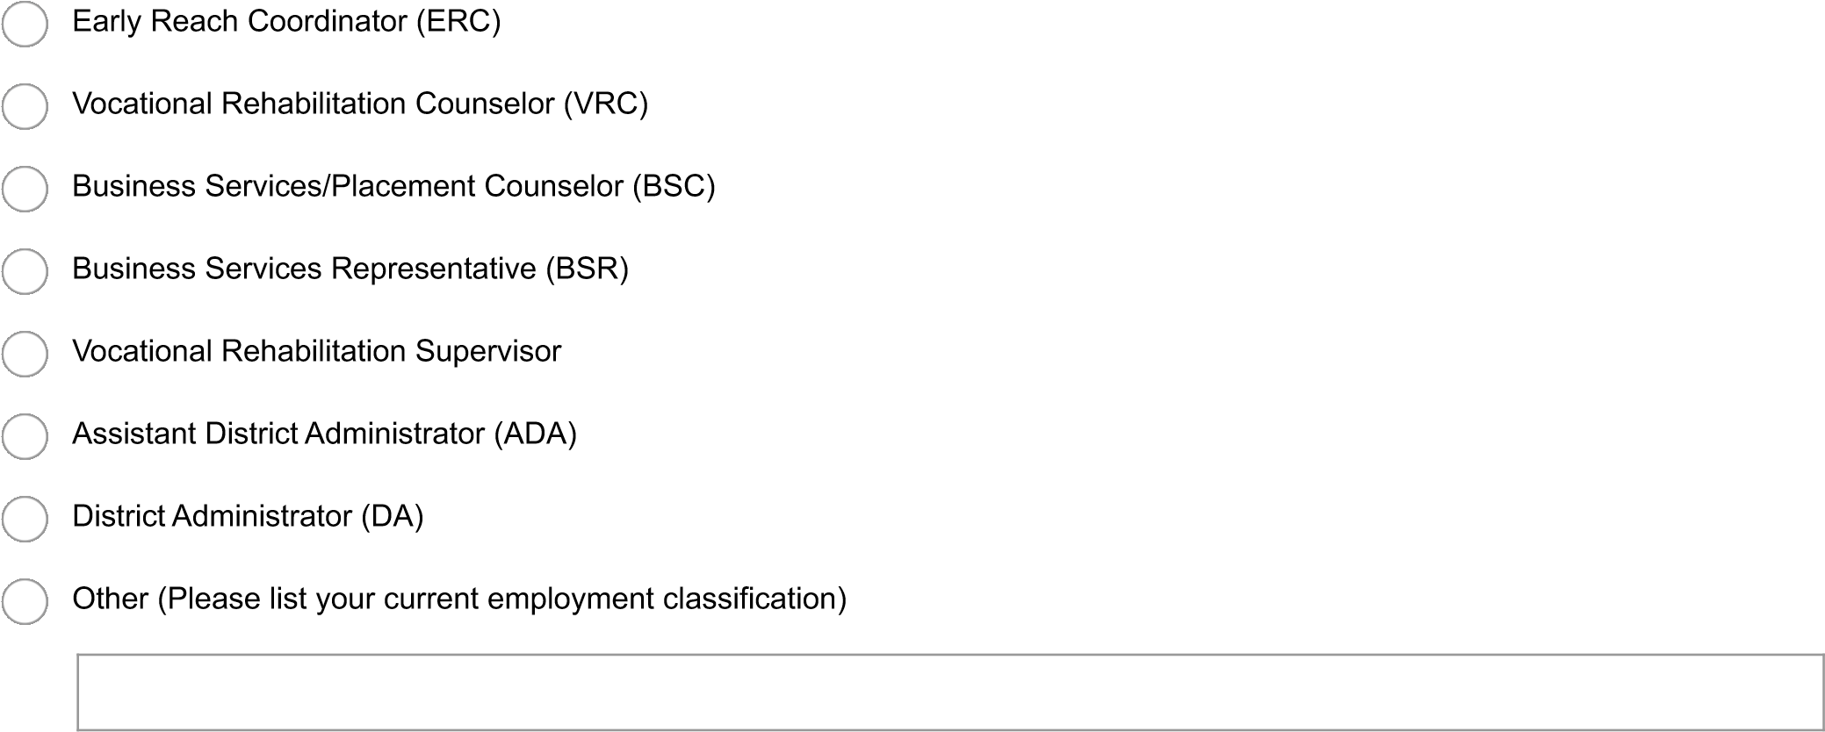
- How long have you been employed with OVR?
 Less than two years
 2-5 years
 6-10 years
 11-15 years
 More than 15 years
- Describe your opinion on the following statement: “Labor market information (LMI) should be included in vocational planning with OVR customers.”
Strongly Disagree Disagree Neutral Agree Strongly Agree

* 4. Do you currently use LMI as part of your vocational planning with OVR customers?
 No
 Yes
Labor Market Information: Awareness and Use
5. Why don’t you use LMI as part of your vocational planning with OVR customers? (Select all that apply)
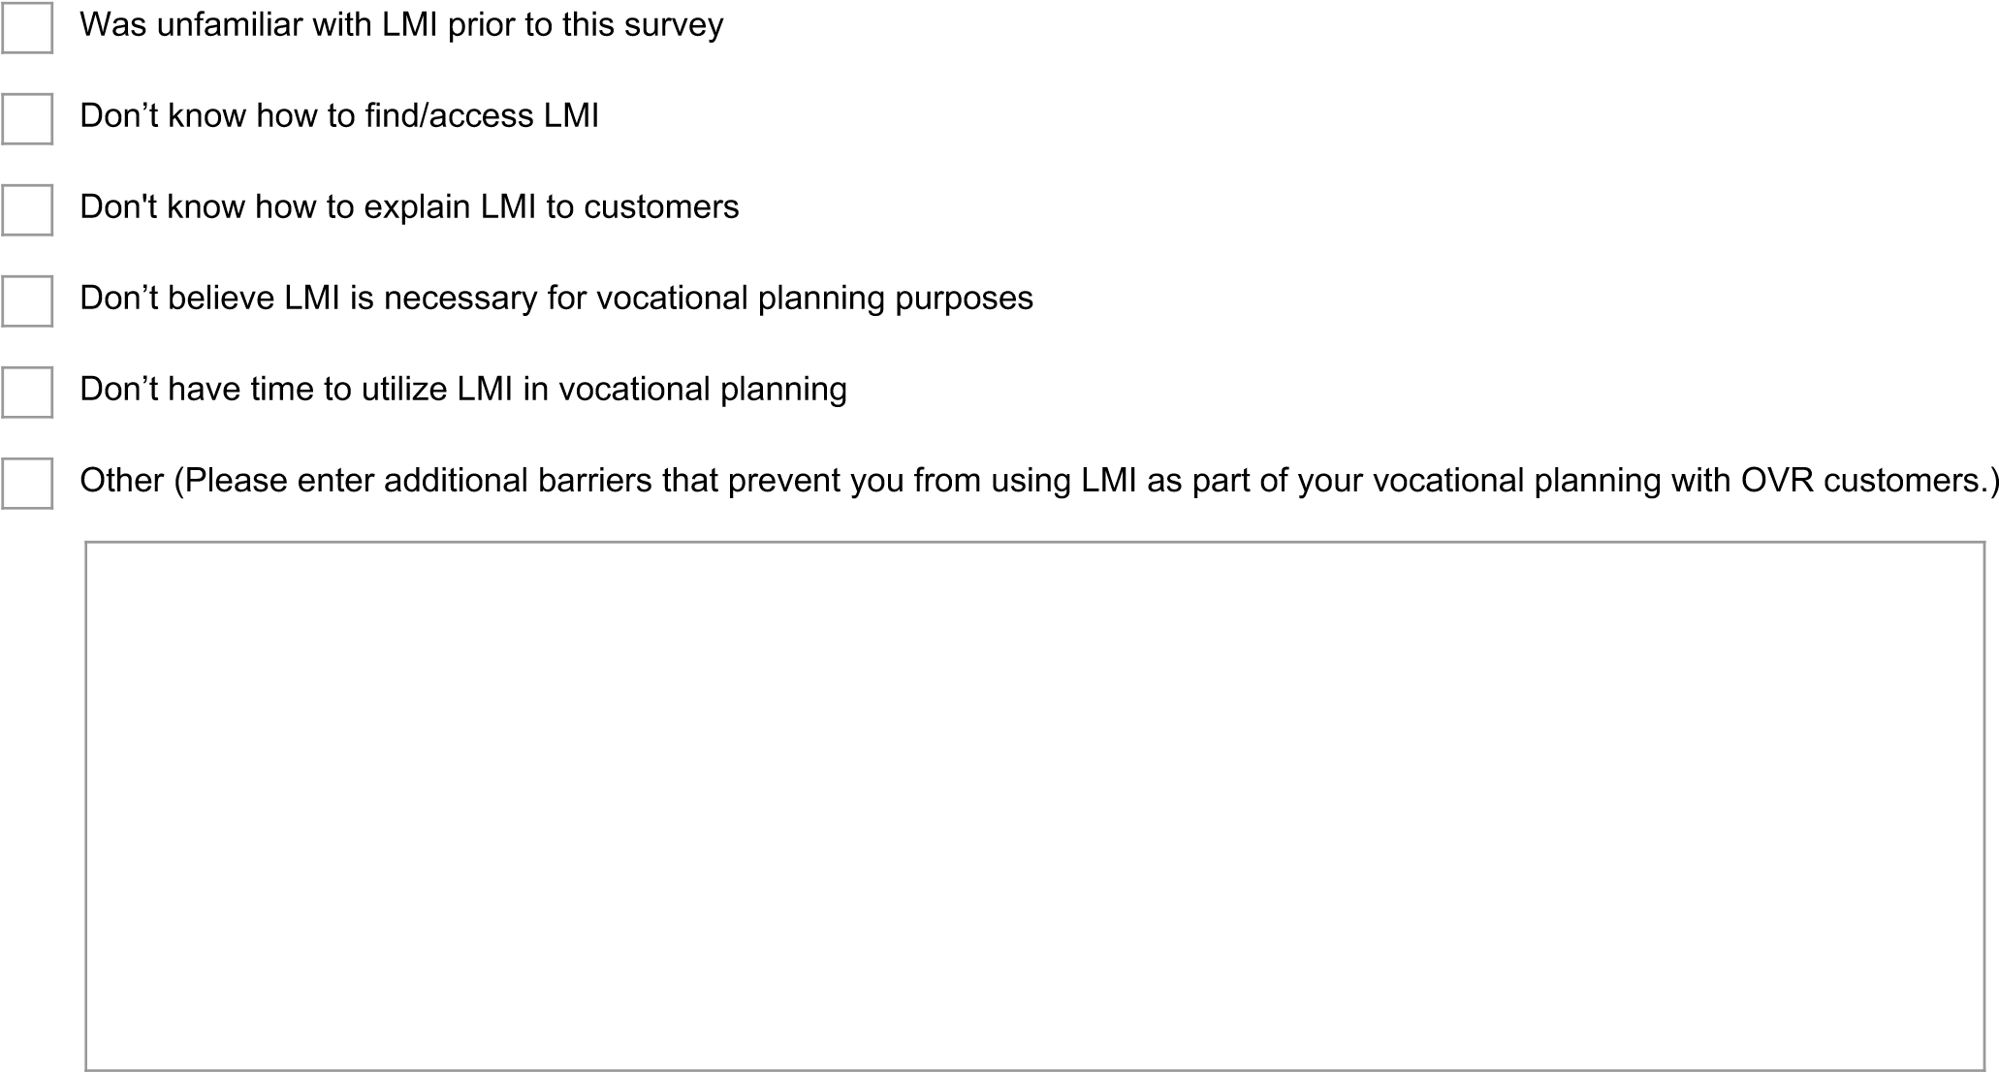
* 6. What type of support would you require to start using labor market information as part of your vocational planning with OVR customers? (Select all that apply. After selecting your answers, click the Next Button to continue to the next question.)
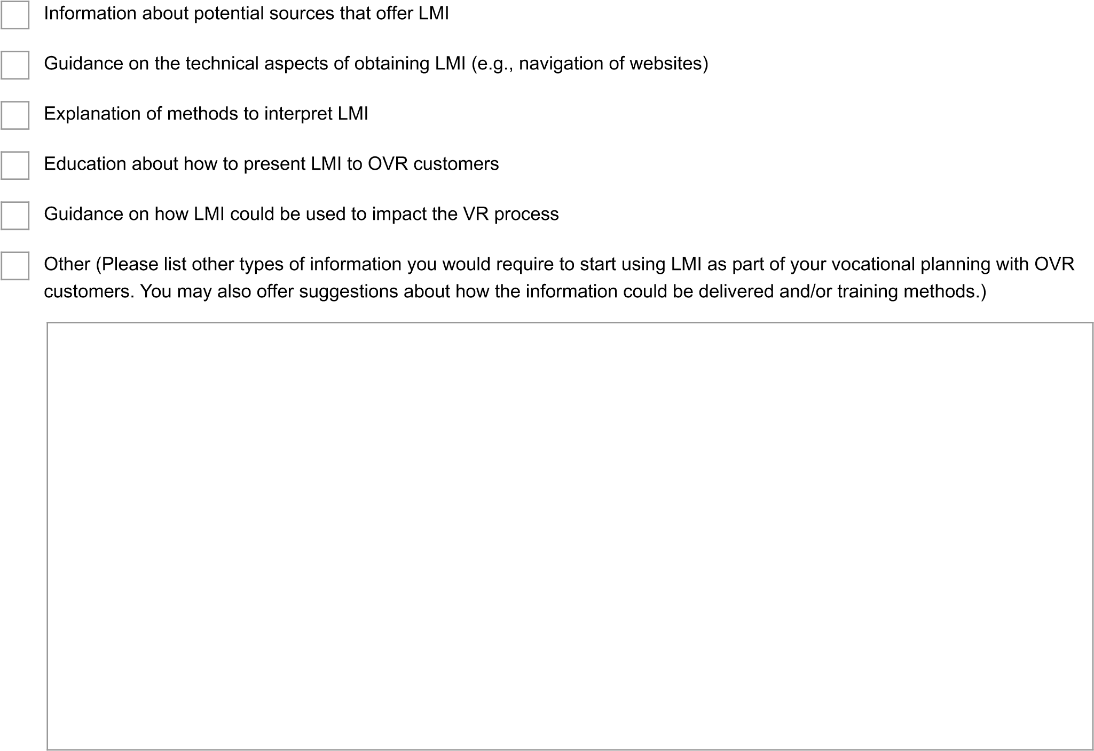
Labor Market Information: Awareness and Use
- What resources do you use to access LMI for vocational planning with OVR customers? (Select all that apply)
O
*
N
e
t
T
O
R
Q
B
u
r
e
a
u

o
f

L
a
b
o
r

S
t
a
t
i
s
t
i
c
s
C
W
I
A
’
s

P
A

W
o
r
k
S
t
a
t
s
O
t
h
e
r

(
P
l
e
a
s
e

S
p
e
c
i
f
y
)
- How often do you incorporate each of the following components of LMI into your vocational planning with OVR customers?
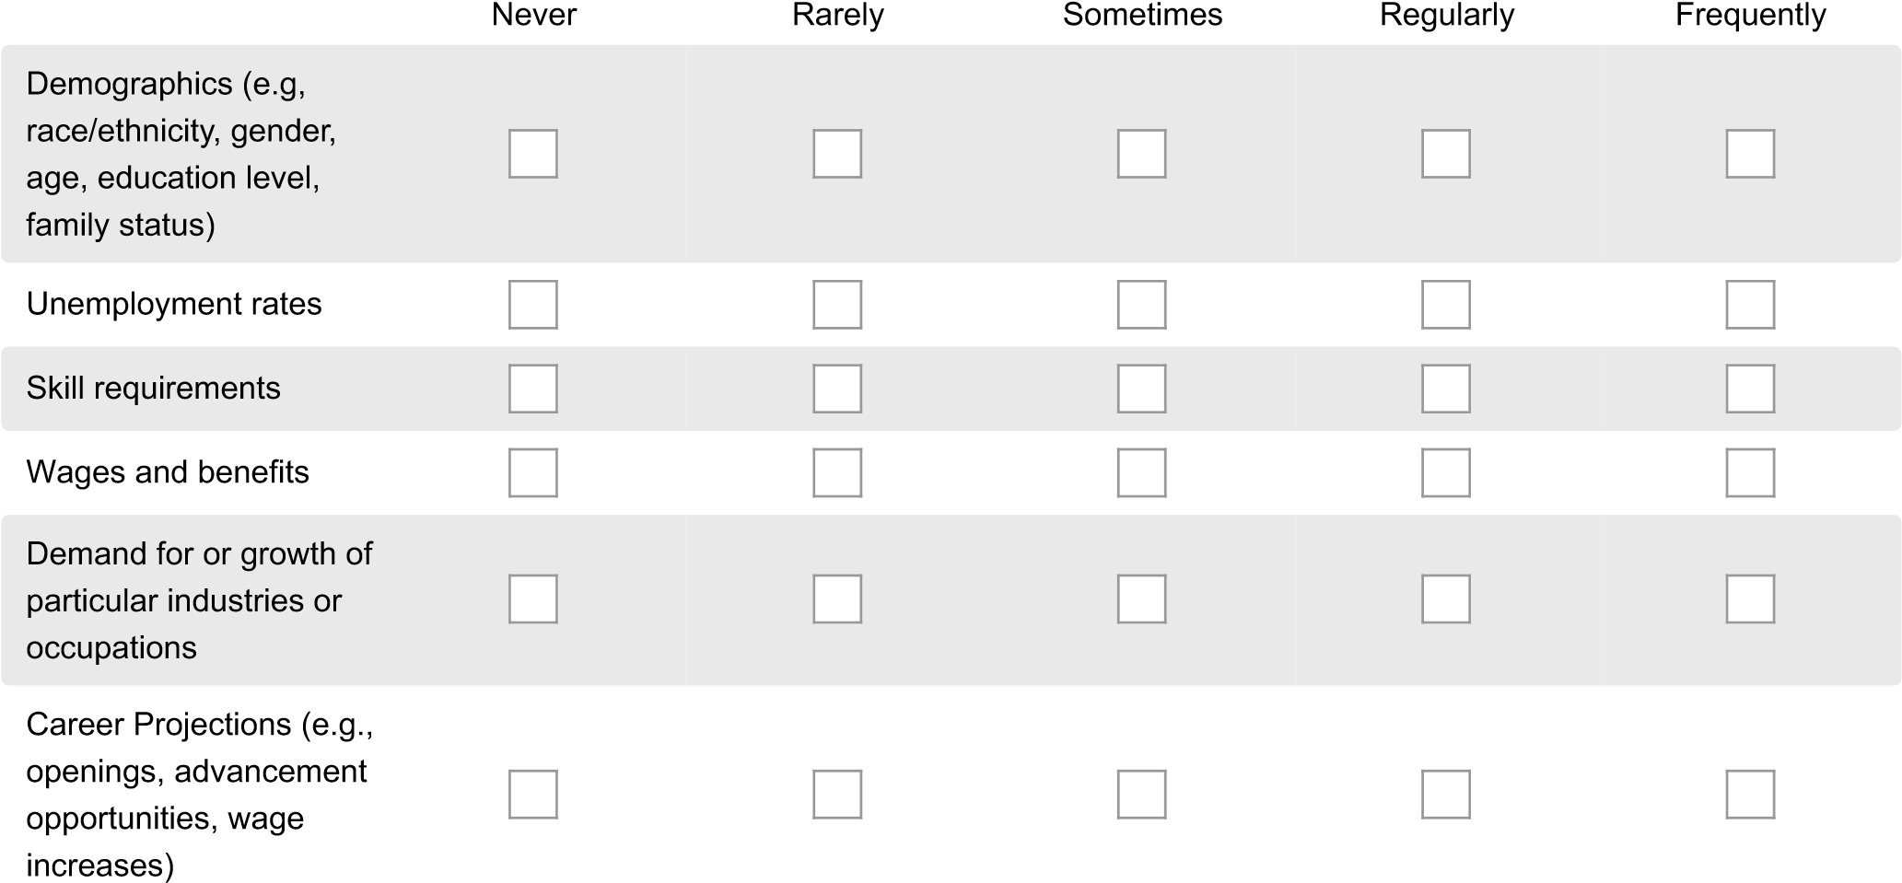
- How often do you use LMI for each of the following purposes?
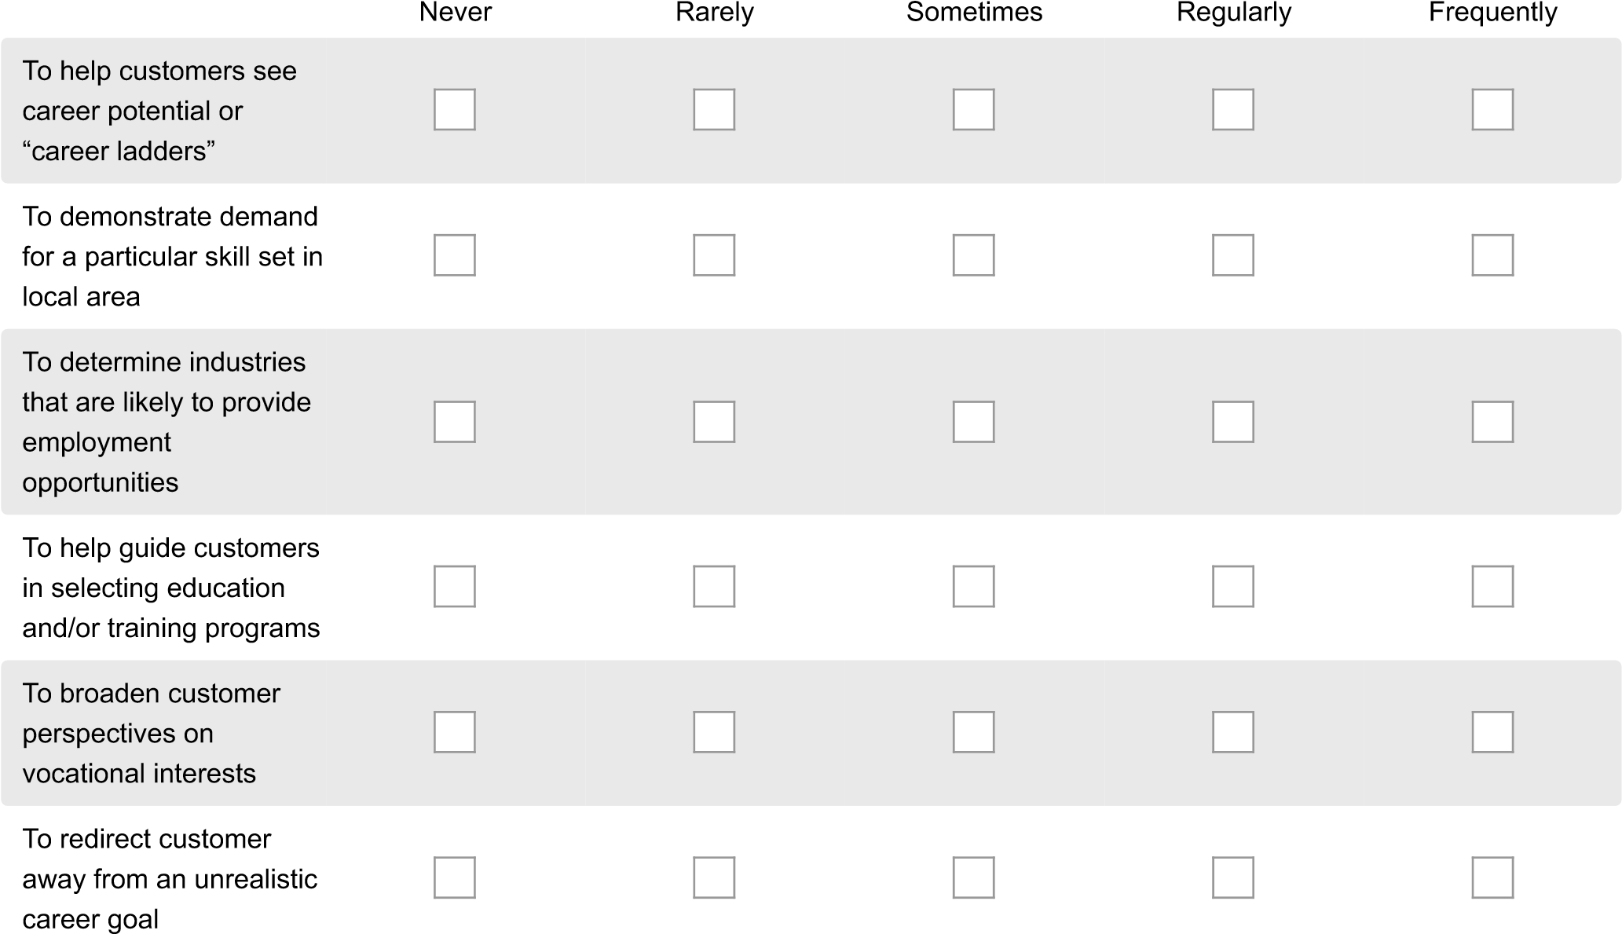

- 10. What type of support or training would you require to increase your use of LMI in your vocational planning with OVR customers? (Select all that apply)
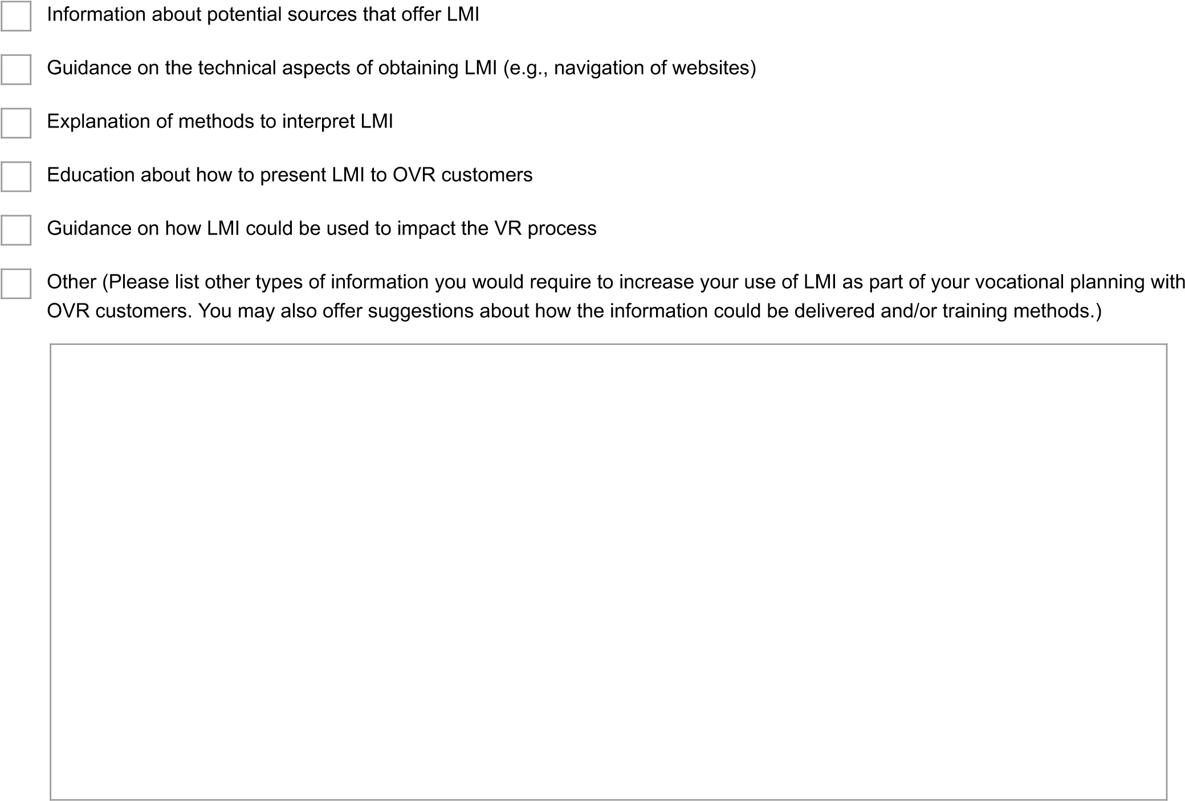
Labor Market Information: Awareness and Use
- 11. Are you familiar with the PA WorkStats website from the Center for Workforce Information & Analysis (CWIA)?
 Yes (Click the Next Button to Continue to the next question.)
 No (Click the Next Button to Skip to Survey End)
Labor Market Information: Awareness and Use
- How often do you access LMI and/or related products from CWIA’s PA WorkStats website?
Never Rarely Sometimes Regularly Frequently

If you have indicated that you Never or Rarely access LMI from CWIA's PA WorkStats website, please explain the reason. You may include suggestions for improvement of website navigation or content, if applicable.

Labor Market Information: Awareness and Use
- Describe the level of difficulty in accessing LMI from CWIA’s PA WorkStats website.
Very Difficult Somewhat Difficult Neutral Somewhat Easy Very Easy

- Please recommend possible improvements to CWIA’s PA WorkStats website. Suggestions might relate to site navigation, available content, document formatting and/or layout, accessibility, etc.

- How useful is each of the following CWIA products as part of your vocational planning with OVR customers?
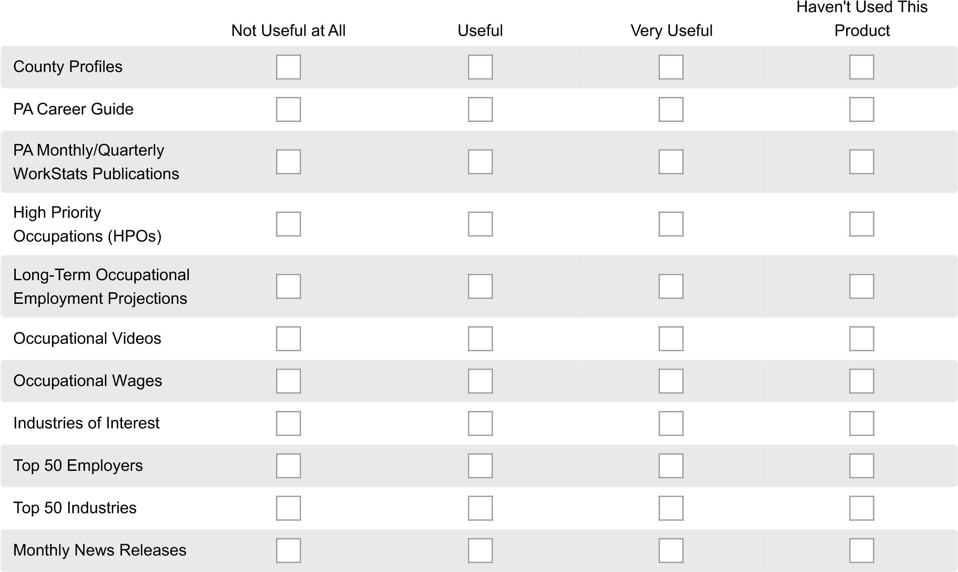
Labor Market Information: Awareness and Use
THANK YOU
Thank you for completing the survey.
Your input will help to develop training opportunities related to Labor Market Information (LMI).
Click the Done Button to submit your survey responses as final.

